**East West University**

**Department of CSE**

**LAB REPORT**

|  |  |  |
| --- | --- | --- |
| **Course Code and Name:**  CSE209 Electrical Circuits | | |
| **Experiment no: 02** | | |
| **Experiment name:**  Series-Parallel DC Circuit and Verification of Kirchhoff’s Laws | | |
| **Semester and Year:**  Fall 2021 |  | |
| **Name of Student:**  D.M. Rafiun -Bin- Masud | **Course Instructor information:**  M Saddam Hossain Khan  Senior Lecturer, Department of Computer Science and Engineering | |
| **Student Id:**  2019-3-60-137 |
| **Date of Report Submitted:**  8 December,2021 | **Pre-Lab Marks:** |  |
| **Post Lab Marks:** |  |
| **TOTAL Marks:** |  |

ABSTRACT

The main objective of this experiment is to induce commonplace with the series-parallel DC circuit. Another objective of this exploration is to apply Kirchhoff’s law for circuits to a two-loop circuit to determine the three streams within the circuit and the electric potential contrasts around each circle. Kirchhoff's Laws portray current in a hub and voltage around a circle. We have tentatively tried Kirchhoff’s Voltage Law and Kirchhoff’s Current Law by measuring the whole of the voltage drops around a few closed ways, and the entirety of the streams at a few hubs. For this try, we required a DC power supply, DC ammeter, DC voltmeter, multimeter, resistors, etc. we can conclude that Kirchhoff’s Laws precisely anticipate the behavior of resistive circuits.

Objectives:

1. To explore and validate Kirchhoff’s laws to better understanding simple DC circuits

2. To get familiar with series-parallel DC circuit.

3. To verify Kirchhoff’s Voltage Law (KVL).

4. To verify Kirchhoff’s Current Law (KCL).

Circuit diagram using PSpice simulator

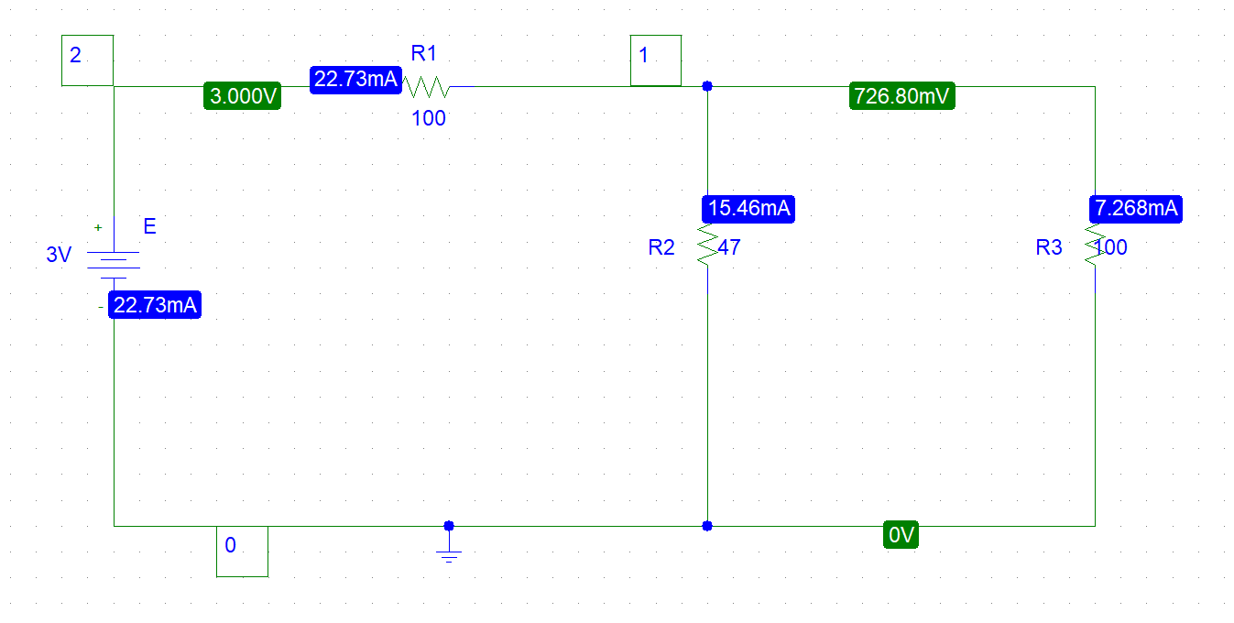

Figure 1: Circuit Diagram

Table 1: Experimental Datasheet.

|  |  |  |  |  |  |  |  |
| --- | --- | --- | --- | --- | --- | --- | --- |
| Measured Value of E(V) | Measured Value of V1(V) | Measured Value of V2(V) | Measured Value of V3(V) | Measured Value of I1(mA) | Measured Value of I2(mA) | Measured Value of I3(mA) | Measured Value of Resistances  (Ω) |
| 3 | (3-0.7268)  =2.2732 | 726.80mV  =0.7268 | 726.80mV  =0.7268 | 22.73 | 15.46 | 7.268 | R1=100  R2=47  R3=100 |

Answers to the Post-Lab Questions:

Answer to the question no:1

Here,

$$E= 3V$$

$$R_{1}= 100 Ω$$

$$R_{2}= 47 Ω$$

$$R_{3}=100 Ω$$

$$R_{P} = R_{2}||R_{3}$$

$$=(47||100) Ω$$

$$= 31.972 Ω$$

$R_{eq}$ = $R_{1}+R_{P}$

    = (100+31.972) $Ω$

    =131.972 Ω

we know that,

$$E=IR$$

$I_{1}= \frac{E}{R_{eq}}$

= $\frac{3}{131.972}$ $mA$

$$= 22.73 mA$$

Applying CDR,

$$I_{2}=\frac{R_{3}×I_{1}}{R_{2}+R_{3}}$$

$=\frac{100×22.732}{47+100}$ $mA$

$=15.463mA$

$$I_{3}=\frac{R_{2}×I_{1}}{R_{2}+R_{3}}$$

$=\frac{47×22.732}{47+100}$ $mA$

$=7.269mA$

$$V_{1}=I_{1}×R_{1}$$

$$=(22.732×100)V$$

$$= 2.273V$$

$$V_{2}=I_{2}×R_{2}$$

$$=(15.463×47)V$$

$$= 0.726V$$

$$V_{3}=I_{3}×R_{3}$$

$$=(7.269×100)V$$

$$= 0.726V$$

Answer to the question no:2

(i)From question (1), we get $V_{2} and V_{3} 0.726V$

$${∴V}_{2}= V_{3}$$

$$(Showed)$$

(ii) $Here,$

$$E= 3V$$

$$V_{1}=2.273V$$

$$V_{2}=0.726V$$

$$V_{1}+V_{2}= \left(2.273+0.726\right)$$

$$=3$$

$$=E$$

$$So, E=V_{1}+V_{2}$$

$(Showed)$

$$(iii) Here,$$

$$I_{1}=22.73mA,$$

$$I_{2}=15.463mA,$$

$$I_{3}=7.269mA.$$

$$I_{2}+I_{3}= (15.463+7.269)mA$$

$$=22.66\sim 22.73mA$$

$$=22.73mA$$

$$So, I_{1}=I_{2}+I_{3}$$

$$(Showed)$$

Result:

After comparing the theoretical & measured values of V1, V2, V3, I1, I2, I3 we found that there some change with the values. This change is occurred by instruments. So, we verified the Kirchhoff’s Laws successfully.

Discussion:

The ammeter must be connected in series with the resistor.

The voltage source which is an active element, must be handled carefully and the supplied voltage should be accurately measured

The voltmeter must be connected parallelly with the resistor.

Conclusion:

While doing the experiments, the readings were taken very carefully. At the end of the experiment, we finally gained practical knowledge that how to work with circuits and use

Kirchhoff’s law. We can be Able to conclude that Kirchhoff’s Voltage and Current Laws precisely anticipate the whole of the voltage drops around a closed way and the entirety of the streams at a hub within the resistive circuits inspected here. Advance, since of the subjective nature of the circuits examined here, we feel sure in concluding that in truth KVL and KCL precisely anticipate the behavior of resistive circuits.

Answers to the Post-Lab Questions:

